**Product Photography Page**

I need a web page for product photography. I need it do few functionalities such as way to contact me and showcasing images of my work.



* I like this navigation bar from a website.
* I would like this kind of navigation bar.
* I don’t want too much on it.
* Logo text
* Contact field
* Work field
* Instagram icon

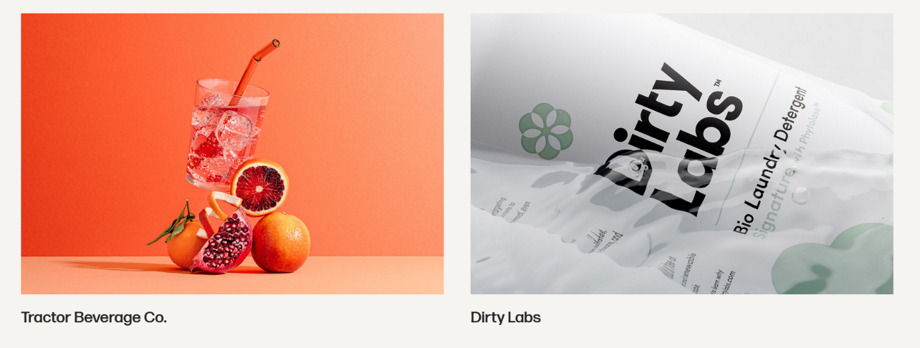

* I would like product images like this displaying on my page.
* Showcase my work and name of the company.
* Images
* Company name

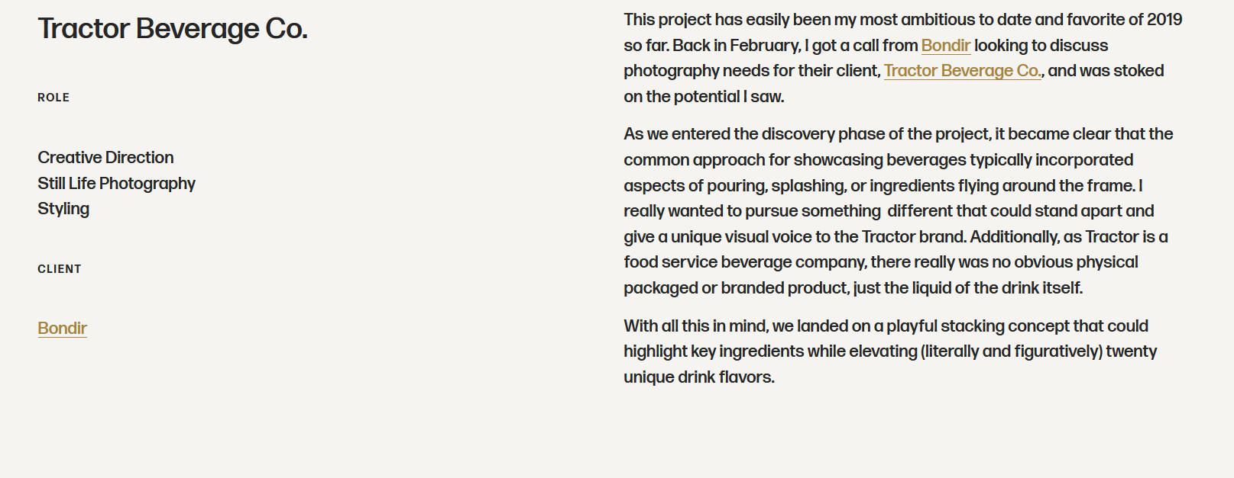

* I need discerptions/text area where I can attribute company and describe my process of shoot.
* Company Title
* Link to company
* Role field for my discerption